Data Structures
Homework Assignment No. 2
Instructor Teacher：M. B. Lin

Problem 1……………………… 2~9
（一）Number generator generate…………………………………2
（二）Build a binary tree……………………………………………3
（三）find_minimum function………………………………………6
（四）find_maximum function………………………………………7
（五）combines and result…………………………………………8

Problem 2……………………11~20
（一）three binary tree traversals……………………………………11
（二）Run the three binary tree traversals……………………………14
（三） Rewrite this program…………………………………………11
（四） Other states……………………………………………………12

Impressions of gains……………………21
--------------------------------------------------------------------------------------------------------------------------------------------
Problem One
--------------------------------------------------------------------------------------------------------------------------------------------
一、Number generator generate numbers ranging from 0 to 1000
（一）流程圖：
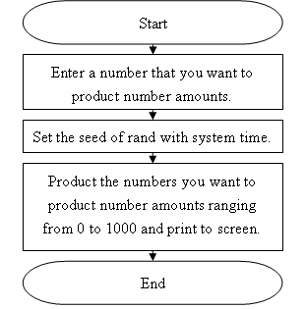
（二）程式碼：
----------------------------------------Program code start----------------------------------------
#include<stdio.h>
#include<stdlib.h>
#include<time.h>
int main(void)
{
printf("\n---------------∮This program is-★-B9502028-★-陳敬翔-create∮---------------\n");
unsigned short num;
printf("Please enter the figure from 0 to 50000 of numbers : ");
scanf("%d",&num);
srand((unsigned)time(NULL));
for(;num>0;num--)
{
printf("%5d ",rand()%50001);
if((num-1)%10==0)
{
printf("\n");
}
}
getch();
return 0;
}
----------------------------------------Program code end----------------------------------------
（三）解說：
本程式可以產生數個從0到1000數目的產生器，你可以依自己的需求要求它產生的個數。
二、Build a binary tree containing at least 20 nodes.
（一）流程圖：
Ⅰ、Insert function：
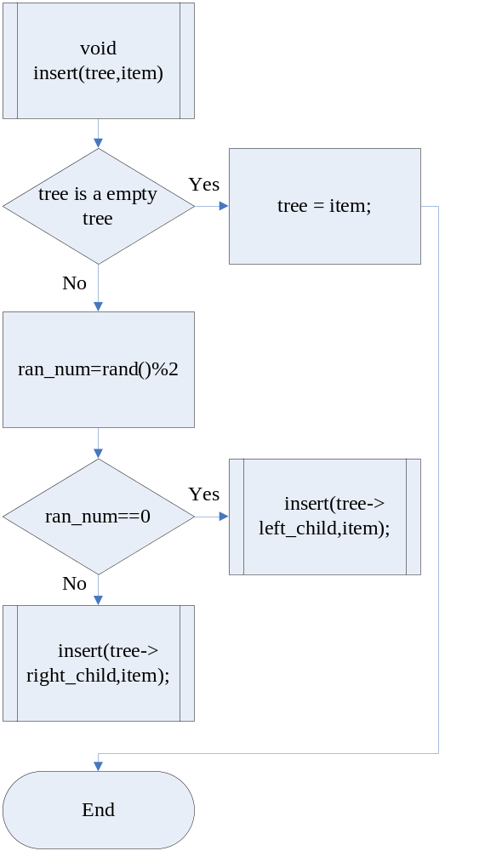
Ⅱ、Main function：
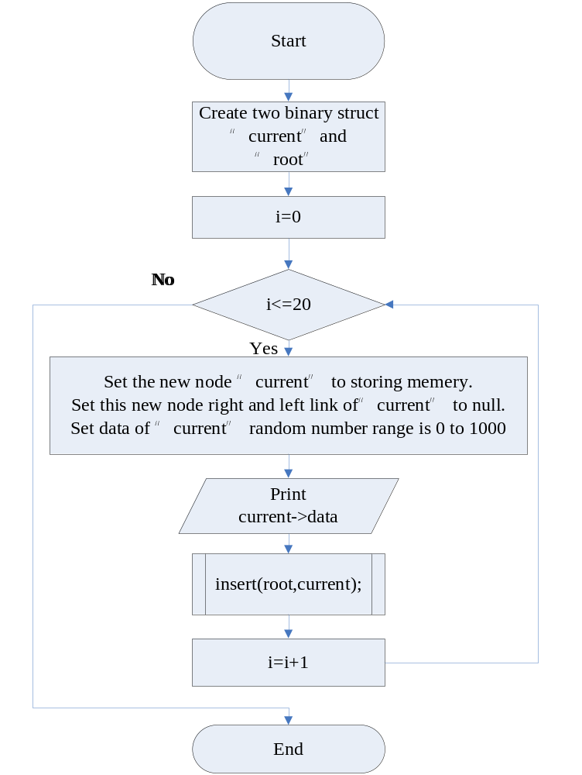
（二）程式碼：
----------------------------------------Program code start----------------------------------------
#include<stdlib.h>
#include<stdio.h>
short min,max;
typedef struct node
{
int data;
struct node *right_child,*left_child;
}
node;
void insert(node **tree,node *item) /*Insert binary tree.*/
{
short ran_num=rand()%2; /*Random number range 0 to 1, to control insert left or reght.*/
if(!(*tree)) /*Whither tree is a empty tree or not.*/
{
*tree = item; /*Create binary tree node.*/
return;
}
if(ran_num==0) /*Go left.*/
{
insert(&(*tree)->left_child,item);
}
else if(ran_num==1) /*Go right.*/
{
insert(&(*tree)->right_child,item);
}
}
int main(void)
{
node *current,*root; /*Create a root and current of binary tree.*/
srand((unsigned)time(NULL)); /*Seed of rand.*/
int i; /*Loop control i.*/
root=NULL; /*Set root is null.*/
printf("Original numbers:\n");
for(i=1;i<=20;i++) /*Start to create binary tree which have twenty node.*/
{
current=(node*)malloc(sizeof(node));/*Set the new node to storing memery.*/
current->left_child=NULL; /*Set this new node link to null.*/
current->right_child=NULL;
current->data=rand()%1001; /*Random number range 0 to 1000.*/
printf("%4d ",current->data);
insert(&root,current); /*Insert binary tree.*/
}
getch();
return 0;
}
----------------------------------------Program code end----------------------------------------
（三）解說：
本程式可以產生二十個節點的二元樹，插入的副程式可以隨機將產生的資料往左或往右增加，形成一個隨機二元樹。
三、Write a find_minimum function to search the smallest key in the tree.
（一）流程圖：
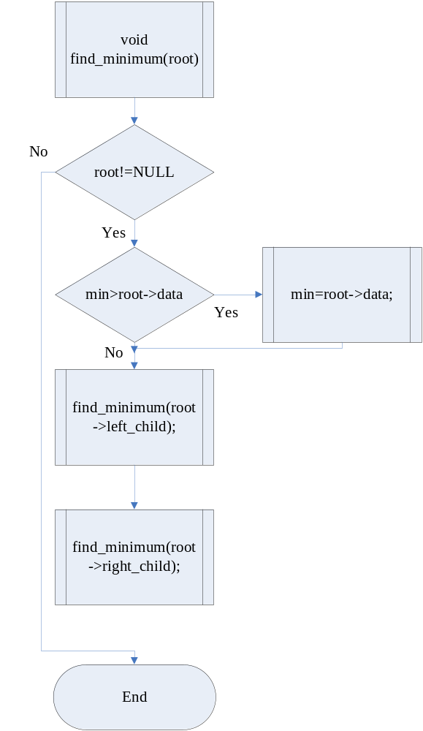
（二）程式碼：
----------------------------------------Program code start----------------------------------------
void find_minimum(node *root) /*Find the minimum number.*/
{
if(root!=NULL)
{
if(min>root->data) /*Use preorder traversal method to find minimum number.*/
{
min=root->data;
}
find_minimum(root->left_child);
find_minimum(root->right_child);
}
}
----------------------------------------Program code end----------------------------------------
（三）解說：
本程式使用前序走訪的方式逐一找出最小的數值，因為任一走訪的方式必定會經過每一個節點，使用這樣的特性，把最小的值找到並在最後印出。
三、Write a find_maximum function to search the largest key in the tree.
（一）流程圖：
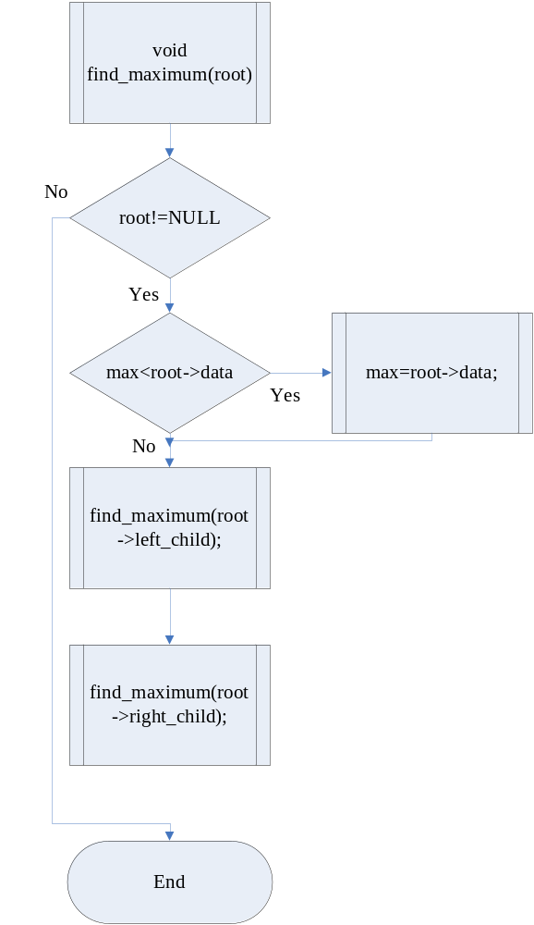
（二）程式碼：
----------------------------------------Program code start----------------------------------------
void find_maximum(node *root) /*Find the maximum number.*/
{
if(root!=NULL)
{
if(max<root->data) /*Use preorder traversal method to find minimum number.*/
{
max=root->data;
}
find_maximum(root->left_child);
find_maximum(root->right_child);
}
}
----------------------------------------Program code end----------------------------------------
（三）解說：
本程式使用前序走訪的方式逐一找出最大的數值，因為任一走訪的方式必定會經過每一個節點，使用這樣的特性，把最大的值找到並在最後印出。
四、The procedure that combines and execution result.
（一）程式碼：
----------------------------------------Program code start----------------------------------------
#include<stdlib.h>
#include<stdio.h>
short min,max;
typedef struct node
{
int data;
struct node *right_child,*left_child;
}
node;
void insert(node **tree,node *item) /*Insert binary tree.*/
{
short ran_num=rand()%2; /*Random number range 0 to 1, to control insert left or reght.*/
if(!(*tree)) /*Whither tree is a empty tree or not.*/
{
*tree = item; /*Create binary tree node.*/
return;
}
if(ran_num==0) /*Go left.*/
{
insert(&(*tree)->left_child,item);
}
else if(ran_num==1) /*Go right.*/
{
insert(&(*tree)->right_child,item);
}
}
void find_minimum(node *root) /*Find the minimum number.*/
{
if(root!=NULL)
{
if(min>root->data) /*Use preorder traversal method to find minimum number.*/
{
min=root->data;
}
find_minimum(root->left_child);
find_minimum(root->right_child);
}
}
void find_maximum(node *root) /*Find the maximum number.*/
{
if(root!=NULL)
{
if(max<root->data) /*Use preorder traversal method to find minimum number.*/
{
max=root->data;
}
find_maximum(root->left_child);
find_maximum(root->right_child);
}
}
int main(void)
{
node *current,*root; /*Create a root and current of binary tree.*/
srand((unsigned)time(NULL)); /*Seed of rand.*/
int i; /*Loop control i.*/
root=NULL; /*Set root is null.*/
printf("Original numbers:\n");
for(i=1;i<=20;i++) /*Start to create binary tree which have twenty node.*/
{
current=(node*)malloc(sizeof(node));/*Set the new node to storing memery.*/
current->left_child=NULL; /*Set this new node link to null.*/
current->right_child=NULL;
current->data=rand()%1001; /*Random number range 0 to 1000.*/
printf("%4d ",current->data);
insert(&root,current); /*Insert binary tree.*/
}
min=root->data; /*Give a reference minimum and maximum.*/
max=root->data;
find_minimum(root); /*Find the minimum number.*/
find_maximum(root); /*Find the maximum number.*/
printf("\nThe smallest key in the tree is %d\n",min);
printf("The largest key in the tree is %d\n",max);
getch();
return 0;
}
----------------------------------------Program code end----------------------------------------
（二）執行結果：
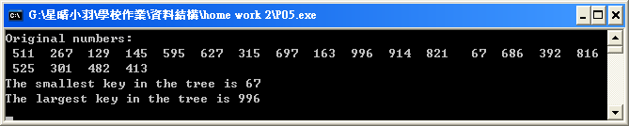
--------------------------------------------------------------------------------------------------------------------------------------------
Problem Two
--------------------------------------------------------------------------------------------------------------------------------------------
一、Code the three binary tree traversals: inorder, preorder and postorder.
（一）Preorder traversal
Ⅰ、流程圖：
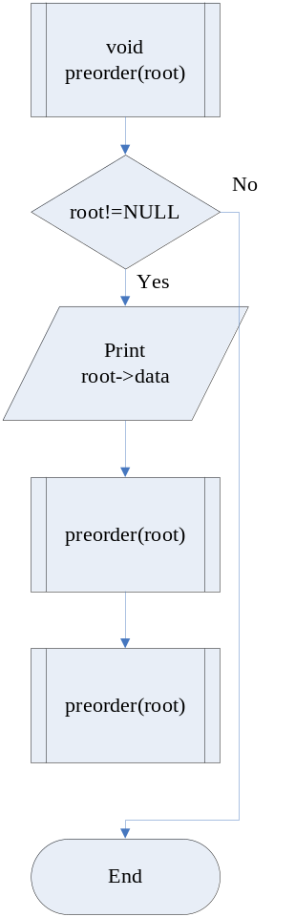
Ⅱ、程式碼：
----------------------------------------Program code start----------------------------------------
void preorder(node *root) /*Preorder traversal*/
{
if(root!=NULL)
{
printf("%4d ",root->data); /*Access and process its root.*/
preorder(root->left_child); /*Traverse its left subtree in preorder.*/
preorder(root->right_child); /*Traverse its right subtree in preorder.*/
}
}
----------------------------------------Program code end----------------------------------------
Ⅲ、解說：
前序走訪方式是走訪到的二元樹節點，就立刻顯示節點資料，走訪的順序是先向樹的左方走直到無法前進後，才轉往右方走。
（二）Ineorder traversal
Ⅰ、流程圖：
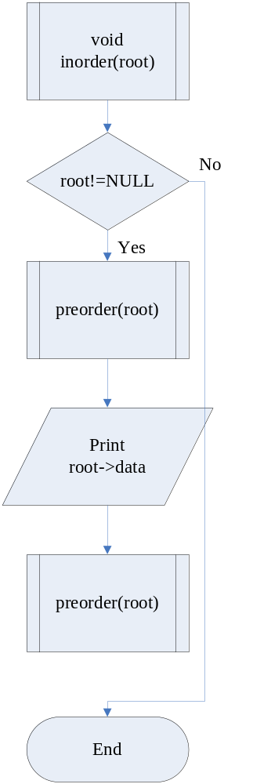
Ⅱ、程式碼：
----------------------------------------Program code start----------------------------------------
void inorder(node *root) /*Ineorder traversal*/
{
if(root!=NULL)
{
inorder(root->left_child); /*Traverse its left subtree in preorder.*/
printf("%4d ",root->data); /*Access and process its root.*/
inorder(root->right_child); /*Traverse its right subtree in preorder.*/
}
}
----------------------------------------Program code end----------------------------------------
Ⅲ、解說：
中序走訪是沿著二元樹的左方往下走，直到無法繼續\前進後，顯示節點，退回到父節點顯示父節點，然後繼續往右走，如果右方都無法前進，顯示節點，再退回到上一層。
（三）Postorder traversal
Ⅰ、流程圖：
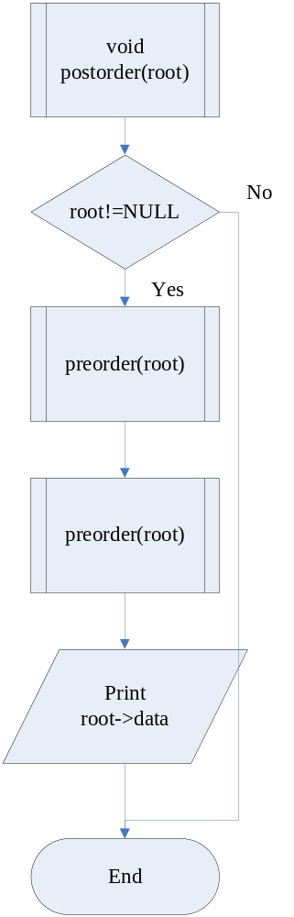
Ⅱ、程式碼：
----------------------------------------Program code start----------------------------------------
void postorder(node *root) /*Postorder traversal*/
{
if(root!=NULL)
{
postorder(root->left_child); /*Traverse its left subtree in preorder.*/
postorder(root->right_child); /*Traverse its right subtree in preorder.*/
printf("%4d ",root->data); /*Access and process its root.*/
}
}
----------------------------------------Program code end----------------------------------------
Ⅲ、解說：
後序走訪方式剛好和前序走訪相反，它是等到節點的兩個子節點都走訪過後才執行處理，顯示節點資料。
二、Rrun the three binary tree traversals to print out the keys in the binary tree.
（一）流程圖：
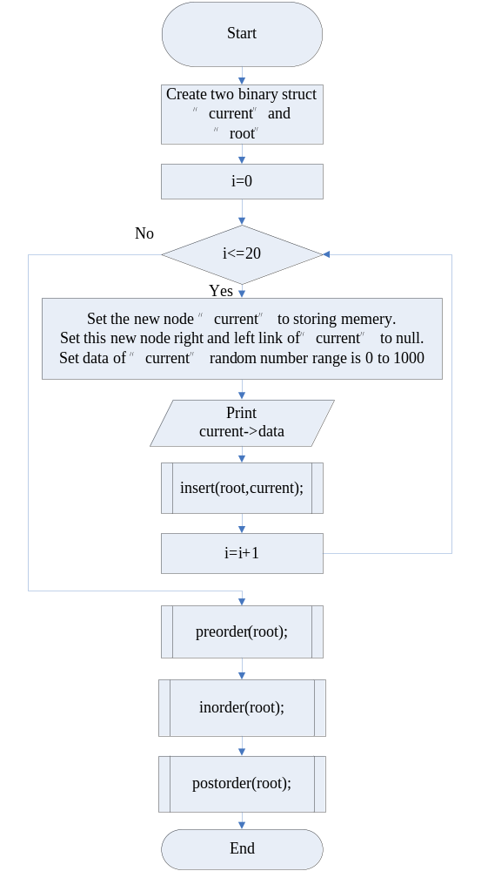
（二）程式碼：
----------------------------------------Program code start----------------------------------------
#include<stdlib.h>
#include<stdio.h>
short min,max;
typedef struct node
{
int data;
struct node *right_child,*left_child;
}
node;
void insert(node **tree,node *item) /*Insert binary tree.*/
{
short ran_num=rand()%2; /*Random number range 0 to 1, to control insert left or reght.*/
if(!(*tree)) /*Whither tree is a empty tree or not.*/
{
*tree = item; /*Create binary tree node.*/
return;
}
if(ran_num==0) /*Go left.*/
{
insert(&(*tree)->left_child,item);
}
else if(ran_num==1) /*Go right.*/
{
insert(&(*tree)->right_child,item);
}
}
void preorder(node *root) /*Preorder traversal*/
{
if(root!=NULL)
{
printf("%4d ",root->data); /*Access and process its root.*/
preorder(root->left_child); /*Traverse its left subtree in preorder.*/
preorder(root->right_child); /*Traverse its right subtree in preorder.*/
}
}
void inorder(node *root) /*Ineorder traversal*/
{
if(root!=NULL)
{
inorder(root->left_child); /*Traverse its left subtree in preorder.*/
printf("%4d ",root->data); /*Access and process its root.*/
inorder(root->right_child); /*Traverse its right subtree in preorder.*/
}
}
void postorder(node *root) /*Postorder traversal*/
{
if(root!=NULL)
{
postorder(root->left_child); /*Traverse its left subtree in preorder.*/
postorder(root->right_child); /*Traverse its right subtree in preorder.*/
printf("%4d ",root->data); /*Access and process its root.*/
}
}
int main(void)
{
node *current,*root; /*Create a root and current of binary tree.*/
srand((unsigned)time(NULL)); /*Seed of rand.*/
int i; /*Loop control i.*/
root=NULL; /*Set root is null.*/
printf("Original numbers:\n");
for(i=1;i<=20;i++) /*Start to create binary tree which have twenty node.*/
{
current=(node*)malloc(sizeof(node));/*Set the new node to storing memery.*/
current->left_child=NULL; /*Set this new node link to null.*/
current->right_child=NULL;
current->data=rand()%1001; /*Random number range 0 to 1000.*/
printf("%4d ",current->data);
insert(&root,current); /*Insert binary tree.*/
}
printf("\nPreorder traversal:\n");
preorder(root); /*Preorder traversal*/
printf("\nIneorder traversal:\n");
inorder(root); /*Preorder inorder*/
printf("\nPostorder traversal:\n");
postorder(root); /*Preorder postorder*/
getch();
return 0;
}
----------------------------------------Program code end----------------------------------------
（三）執行結果：
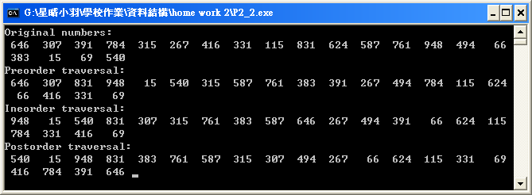
（四）樹的形成：
根據前序走訪與中序走訪，可以找出並畫出這棵二元樹，步驟如下：
前序走訪：646, 307, 831, 948, 15, 540, 315, 587, 761, 383, 391, 267, 494, 784, 115, 624, 66, 416, 331, 69
中序走訪：948, 15, 540, 831, 307, 315, 761, 383, 587, 646, 267, 494, 391, 66, 624, 115, 784, 331, 416, 69
Ⅰ、前序走訪：646, 307, 831, 948, 15, 540, 315, 587, 761, 383, 391, 267, 494, 784, 115, 624, 66, 416, 331, 69
中序走訪：948, 15, 540, 831, 307, 315, 761, 383, 587, 646, 267, 494, 391, 66, 624, 115, 784, 331, 416, 69
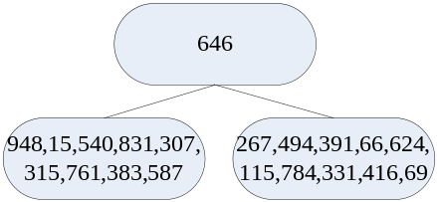
Ⅱ、前序走訪：646, 307, 831, 948, 15, 540, 315, 587, 761, 383, 391, 267, 494, 784, 115, 624, 66, 416, 331, 69
中序走訪：948, 15, 540, 831, 307, 315, 761, 383, 587, 646, 267, 494, 391, 66, 624, 115, 784, 331, 416, 69
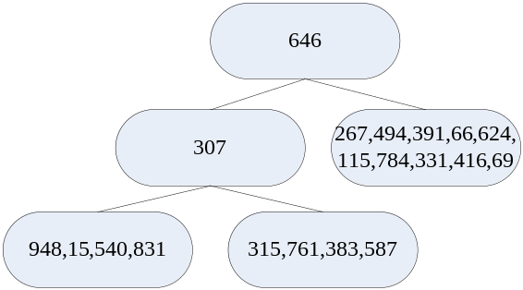
Ⅲ、前序走訪：646, 307, 831, 948, 15, 540, 315, 587, 761, 383, 391, 267, 494, 784, 115, 624, 66, 416, 331, 69
中序走訪：948, 15, 540, 831, 307, 315, 761, 383, 587, 646, 267, 494, 391, 66, 624, 115, 784, 331, 416, 69
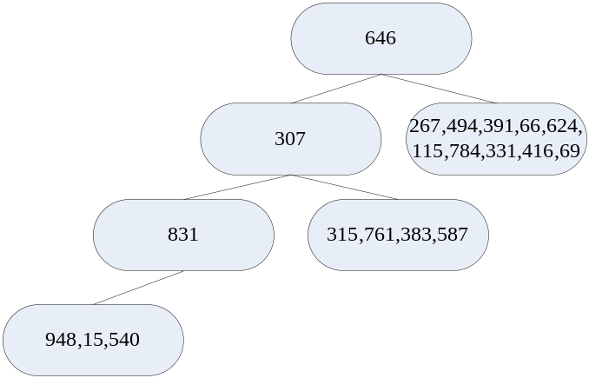
Ⅳ、前序走訪：646, 307, 831, 948, 15, 540, 315, 587, 761, 383, 391, 267, 494, 784, 115, 624, 66, 416, 331, 69
中序走訪：948, 15, 540, 831, 307, 315, 761, 383, 587, 646, 267, 494, 391, 66, 624, 115, 784, 331, 416, 69
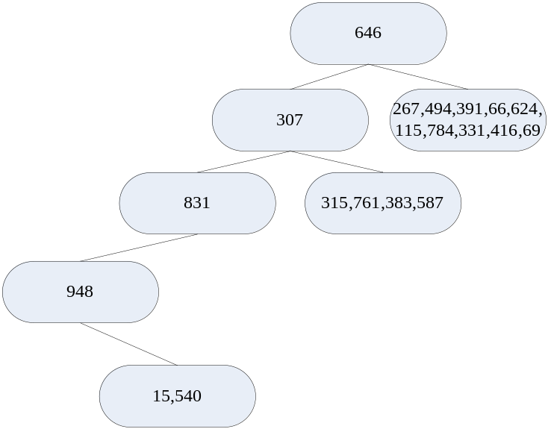
Ⅴ、前序走訪：646, 307, 831, 948, 15, 540, 315, 587, 761, 383, 391, 267, 494, 784, 115, 624, 66, 416, 331, 69
中序走訪：948, 15, 540, 831, 307, 315, 761, 383, 587, 646, 267, 494, 391, 66, 624, 115, 784, 331, 416, 69
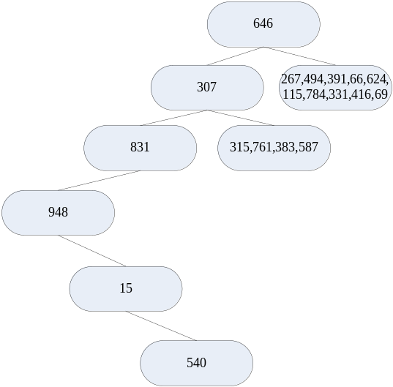
Ⅵ、前序走訪：646, 307, 831, 948, 15, 540, 315, 587, 761, 383, 391, 267, 494, 784, 115, 624, 66, 416, 331, 69
中序走訪：948, 15, 540, 831, 307, 315, 761, 383, 587, 646, 267, 494, 391, 66, 624, 115, 784, 331, 416, 69
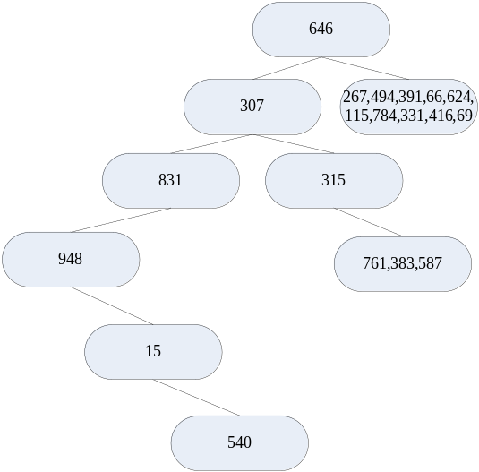
Ⅶ、前序走訪：646, 307, 831, 948, 15, 540, 315, 587, 761, 383, 391, 267, 494, 784, 115, 624, 66, 416, 331, 69
中序走訪：948, 15, 540, 831, 307, 315, 761, 383, 587, 646, 267, 494, 391, 66, 624, 115, 784, 331, 416, 69
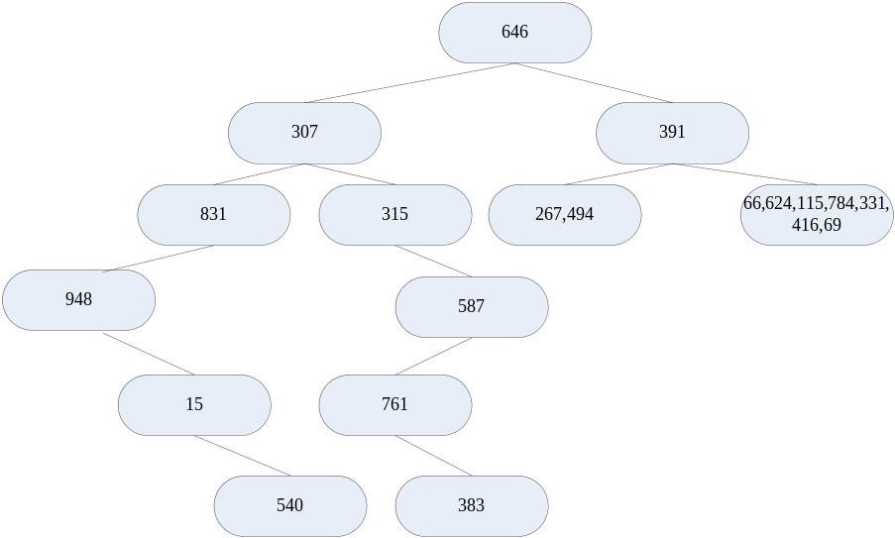
Ⅷ、前序走訪：646, 307, 831, 948, 15, 540, 315, 587, 761, 383, 391, 267, 494, 784, 115, 624, 66, 416, 331, 69
中序走訪：948, 15, 540, 831, 307, 315, 761, 383, 587, 646, 267, 494, 391, 66, 624, 115, 784, 331, 416, 69
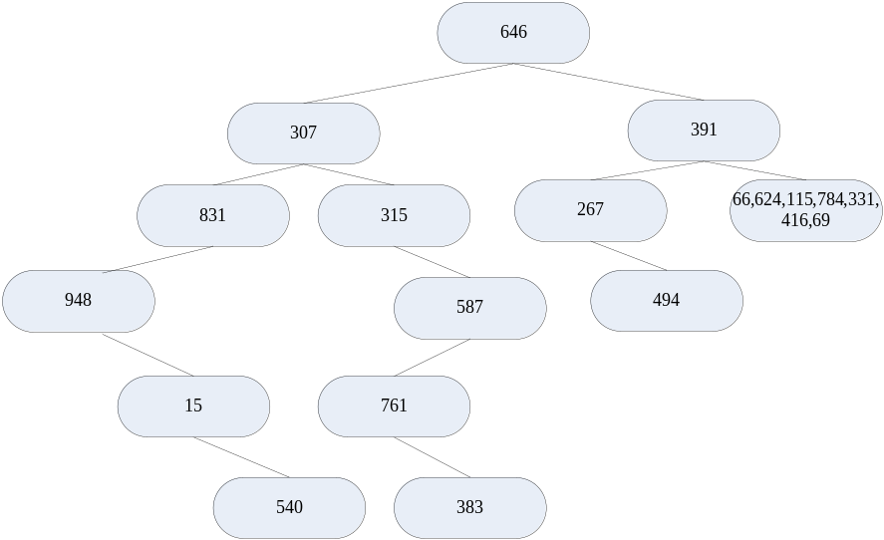
Ⅸ、前序走訪：646, 307, 831, 948, 15, 540, 315, 587, 761, 383, 391, 267, 494, 784, 115, 624, 66, 416, 331, 69
中序走訪：948, 15, 540, 831, 307, 315, 761, 383, 587, 646, 267, 494, 391, 66, 624, 115, 784, 331, 416, 69
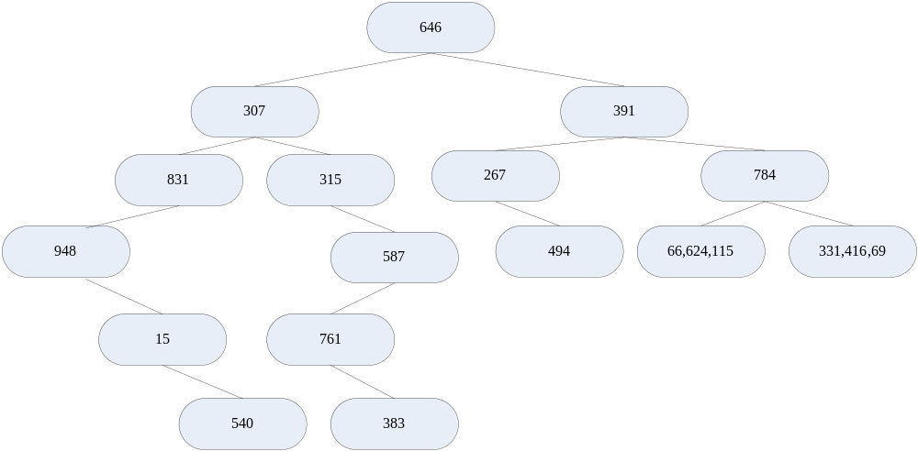
Ⅸ、前序走訪：646, 307, 831, 948, 15, 540, 315, 587, 761, 383, 391, 267, 494, 784, 115, 624, 66, 416, 331, 69
中序走訪：948, 15, 540, 831, 307, 315, 761, 383, 587, 646, 267, 494, 391, 66, 624, 115, 784, 331, 416, 69
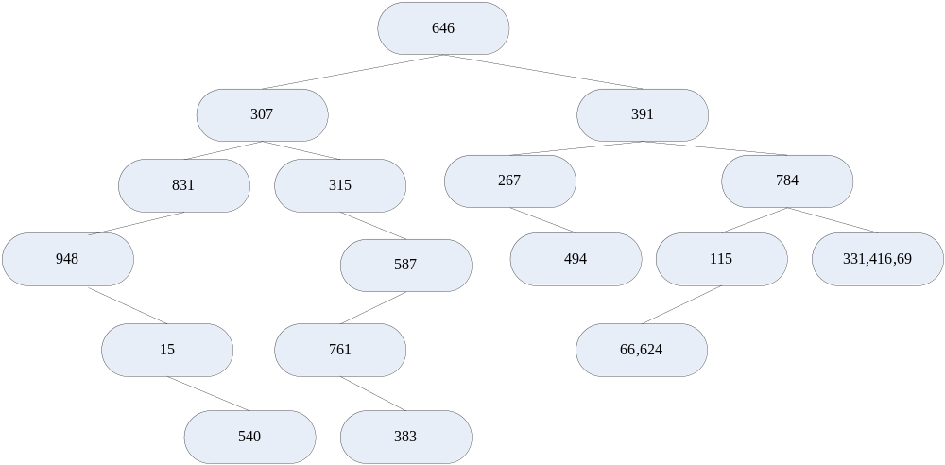
Ⅹ、前序走訪：646, 307, 831, 948, 15, 540, 315, 587, 761, 383, 391, 267, 494, 784, 115, 624, 66, 416, 331, 69
中序走訪：948, 15, 540, 831, 307, 315, 761, 383, 587, 646, 267, 494, 391, 66, 624, 115, 784, 331, 416, 69
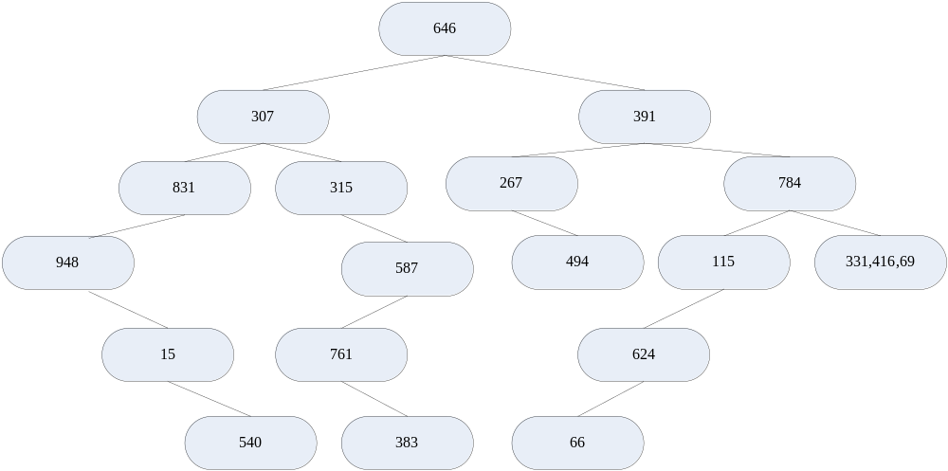
ⅩⅠ、前序走訪：646, 307, 831, 948, 15, 540, 315, 587, 761, 383, 391, 267, 494, 784, 115, 624, 66, 416, 331, 69
中序走訪：948, 15, 540, 831, 307, 315, 761, 383, 587, 646, 267, 494, 391, 66, 624, 115, 784, 331, 416, 69
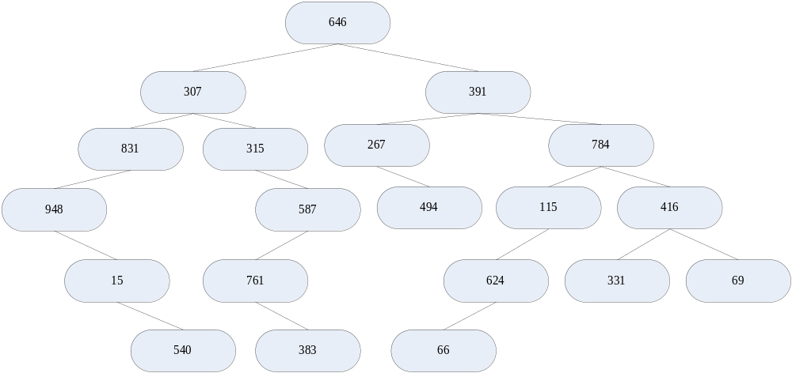
Finish!!
--------------------------------------------------------------------------------------------------------------------------------------------
心得感想
--------------------------------------------------------------------------------------------------------------------------------------------
這次是第二次作業，是探討一些二元樹的相關問題，感謝老師給予這份作業，讓我們可以實際去操作，並且製作自己第一棵樹，除了探討二元樹的搜尋之外，還有日常生活上的應用，像是家族族譜與公司管理。在撰寫過程中，遇上了很多問題，因此花了很多時間去想，花了很多時間去尋求資料、去摸索、去理解、不斷的去嘗試，雖然過程艱辛的滋味難以言喻，但是完成的喜悅卻甘如露雨，逐一解決每個問題，也讓自己的觀念越來越清楚，也學習得更多，再次感謝老師給了這樣的機會！上課辛苦了！

